**MESD LMS Documentation – Add/edit/delete schools departments**

**Purpose**

To facilitate the addition and editing of MESD LMS school site.

**Background**

This module handles requests directly from Super Admins within the Moodle system, allowing addition of departments and users into the departments.

**Usage**

**Create new department and add users to department**

1. Log in to Moodle as a Super admin.
2. Go to *‘Dashboard’,* turn on ‘Edit mode’ then *‘Add a block’.*
3. Click on *‘Department Navigation’* to add the Department Navigation block.
4. Select *‘Department Manager’* from the block then *‘Create Department’*.

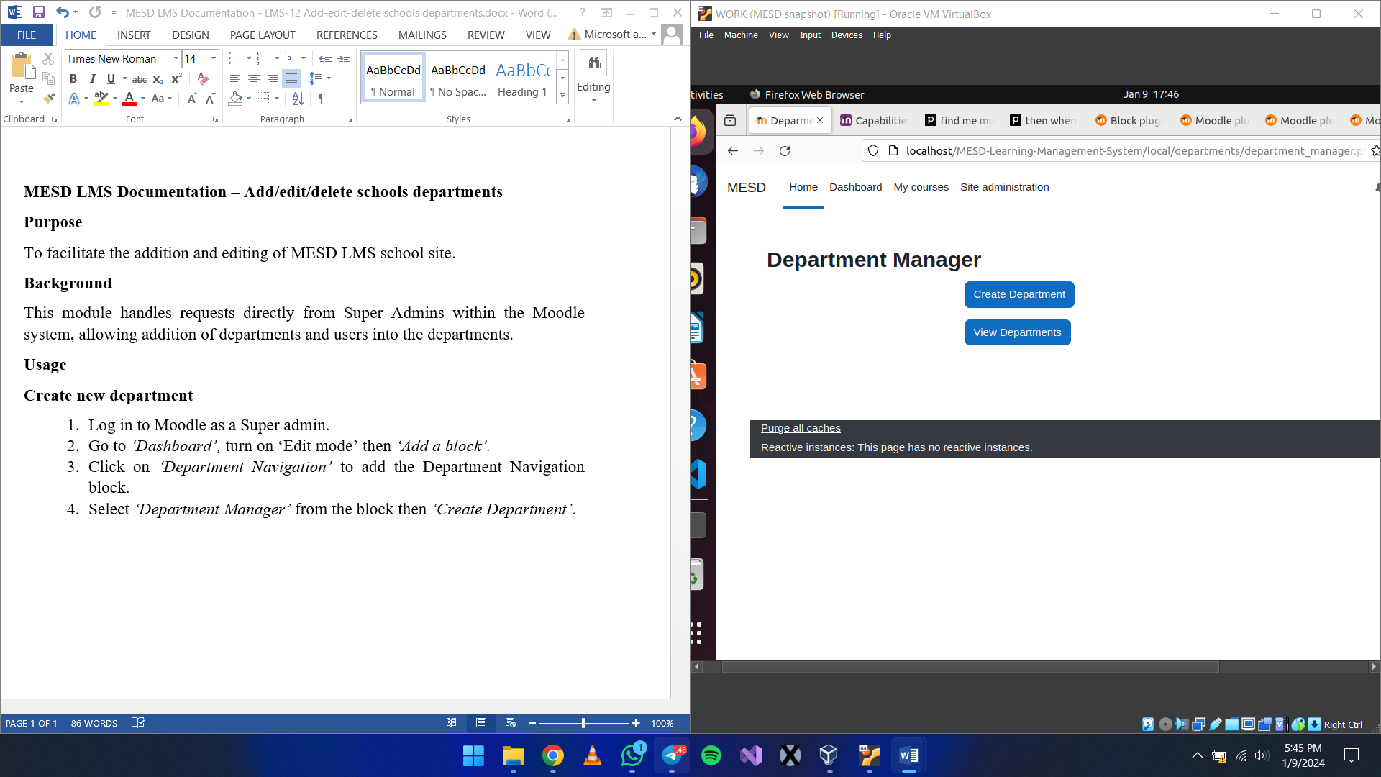

1. Enter the department name and select the users you want to add from the dropdown or search.

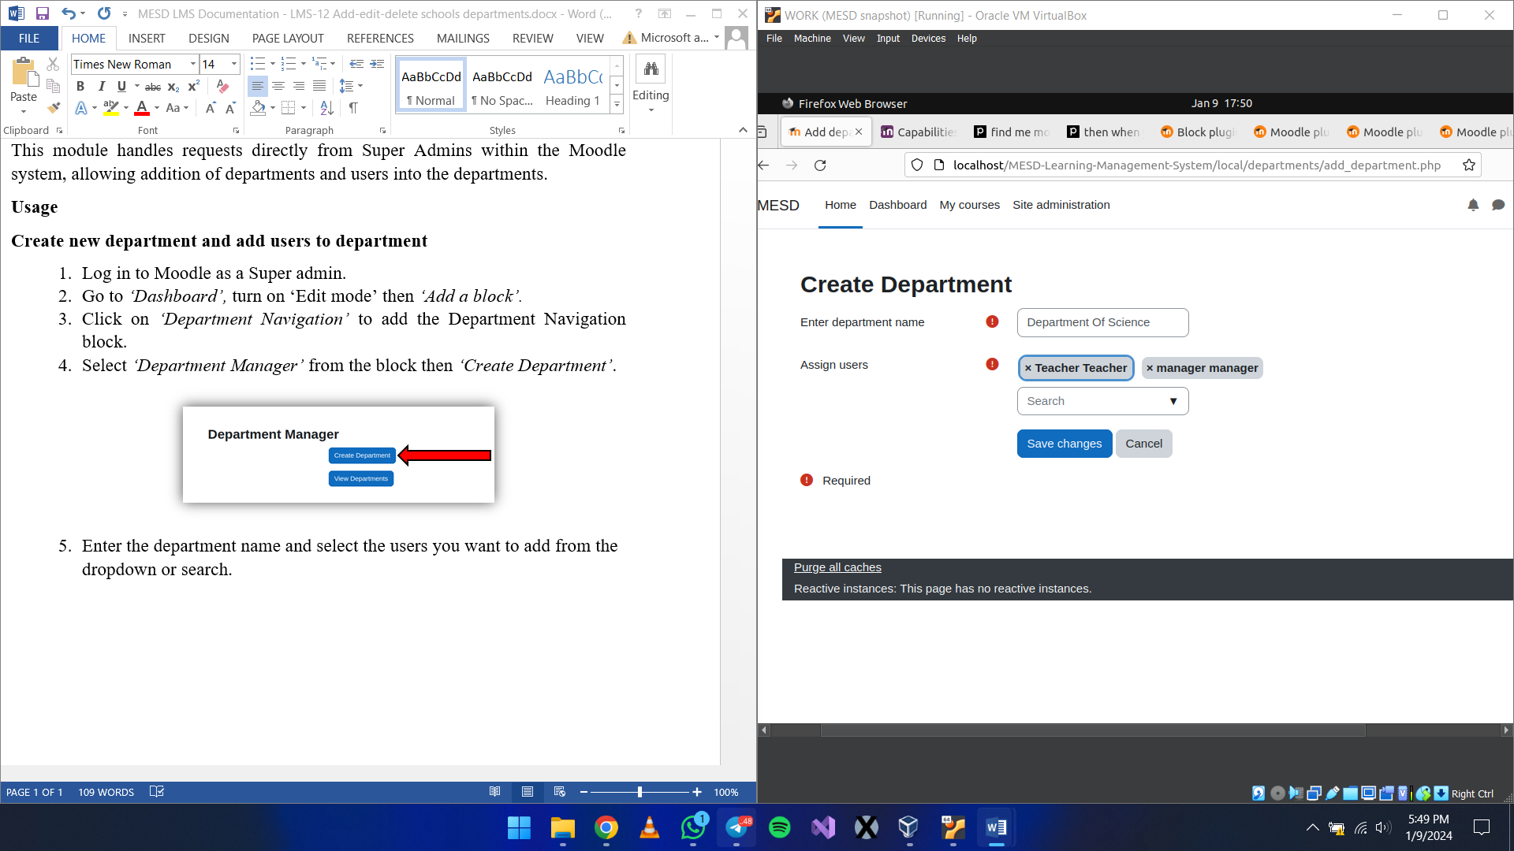

1. Finish and save changes.

**View departments**

1. While in the department manager page, select *‘View Departments’.* This page allows you to view all the departments.
2. Edit
   1. Click on the *‘Edit’* button

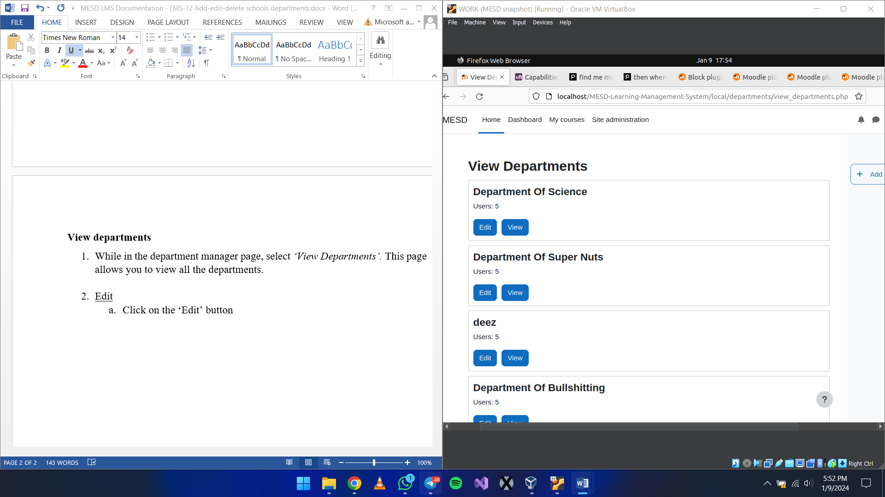

* 1. Re-edit the department details and assign new users if you want.

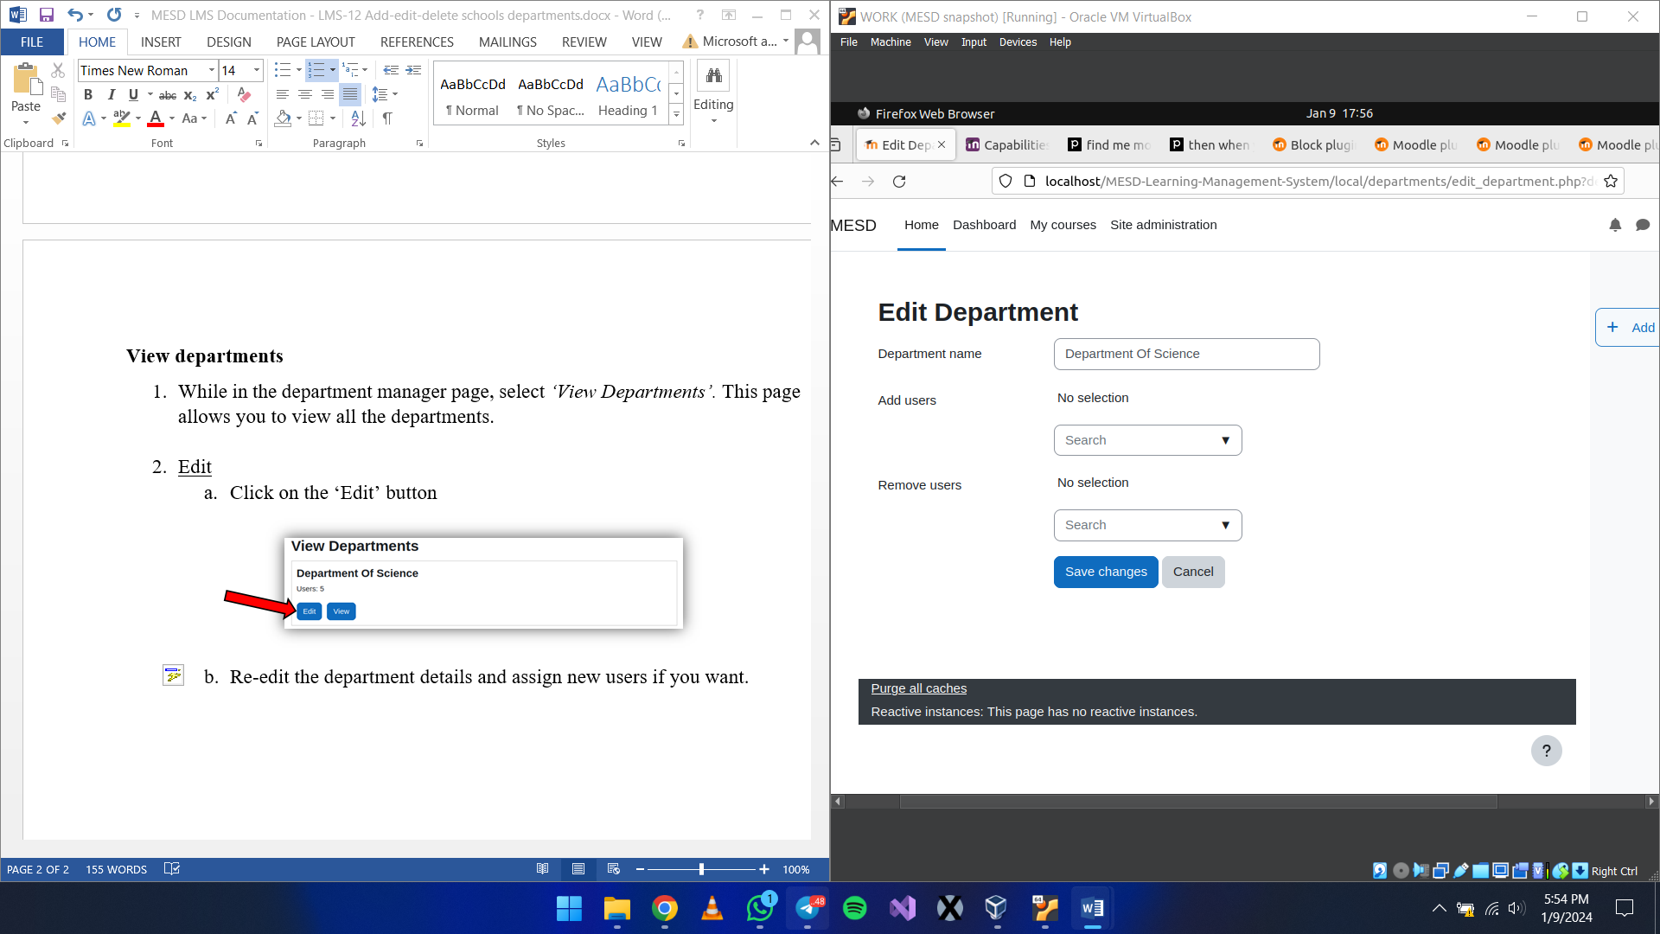

* 1. Save changes.

1. View
   1. Click on the *‘View’* button to view detailed information about the department.

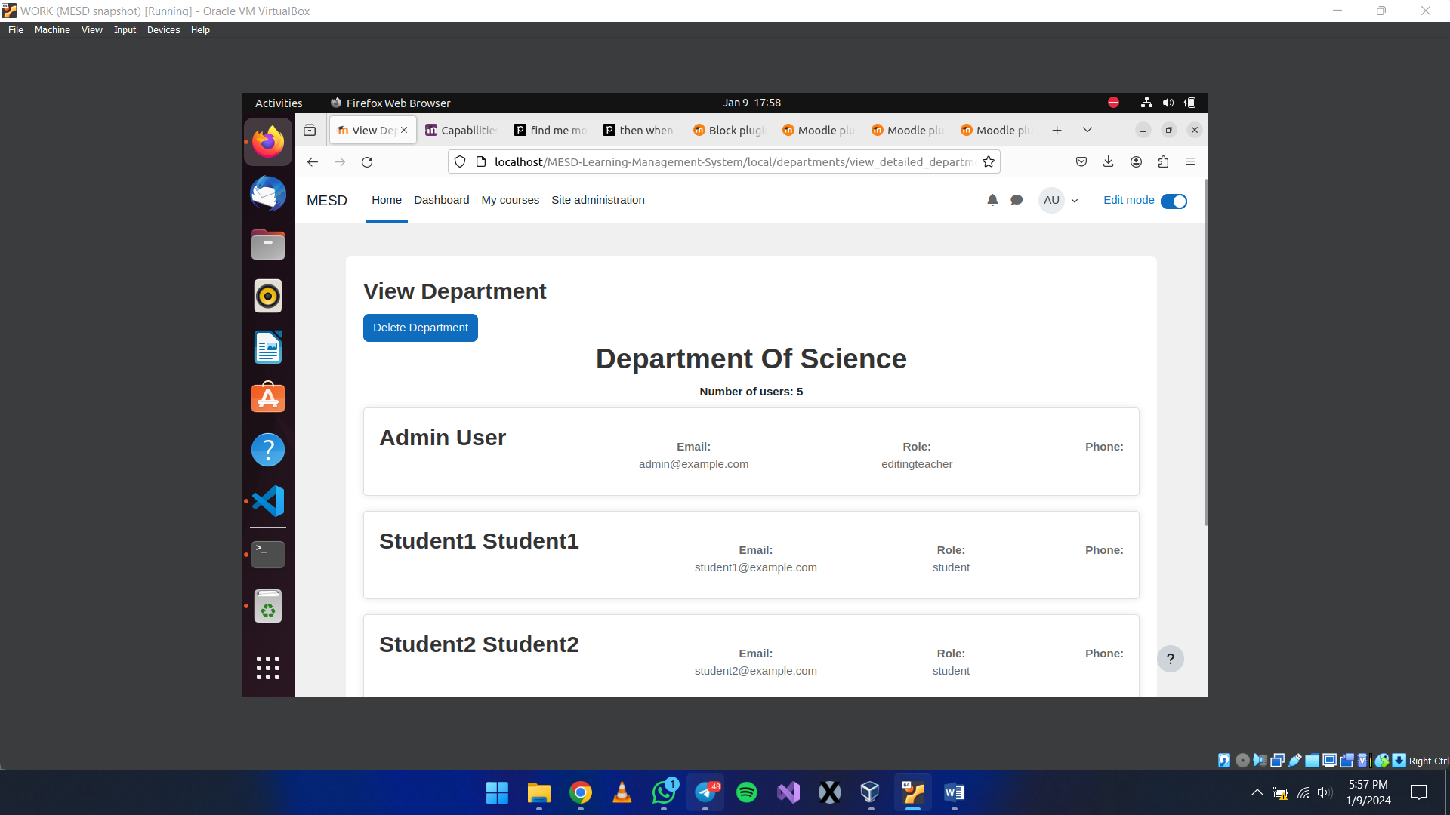

**Developer Information**

Capabilities

local/departments:adddepartments : Allows users to add departments

local/departments:deletedepartments : Allows users to delete departments

local/departments:viewdepartmentmanager : Allows users to view department manager

local/departments:editdepartment : Allows users to edit departments (change name, add users, remove users)

local/departments:viewdepartments : Allows users to view departments

local/departments:viewdetaileddepartment : Allows users to view detailed department information (names of users in departments)